**Feature Document: Integration with EPIC for MediPortal**

**Objective**

To replace the existing integration with the Best Practice Management System in MediPortal with EPIC. All patient and doctor details will be retrieved from EPIC. This document outlines the features and functionalities required for the updated system.

Note all patient details, Medical Conditions, past history and practitioner details and appointments need to be drawn from EPIC.

Care plans and transcribed notes need to be saved in EPIC under the respective patient record.

**User Journey**

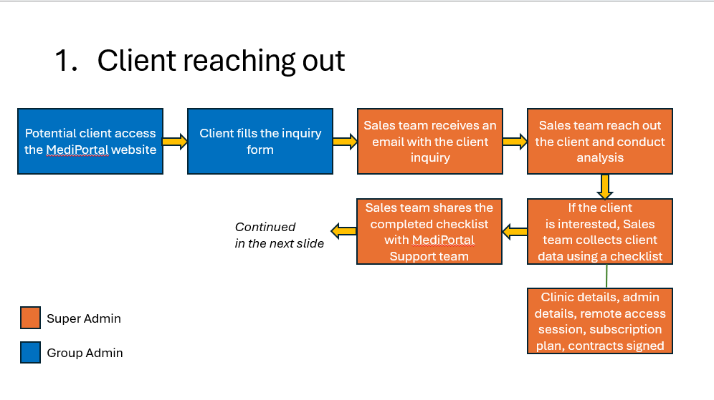

**Key Features**

**Admin Portal**

1. **Super Admin Functionalities:**
   * **Organization Management:**
     + Create organizations and create medical centers.
   * **User Management:**
     + Create users (Eg: group admin or clinic admin).
     + Assign users to respective medical centers.
   * **Subscription Management:**
     + Assign subscription plans to medical centers (Trail / Paid).
   * **Credentials Sharing:**
     + Share login credentials with admin users via email.
2. **Group Admin Functionalities:**
   * **Dashboard Access:**
     + View financial dashboard
     + item summary,
     + pay-by-billing and pay-by-receipt calculations.
     + Generate tax invoices.
   * **Practitioner Synchronization:**
     + Sync practitioners from EPIC into MediPortal.
   * **Subscription Updates:**
     + Modify subscription plans for assigned medical centers.

**Doctor Portal**

1. **Credentials and Login:**
   * Receive login credentials via SMS after synchronization by admin.
2. **Dashboard Access:**
   * View personal financial dashboard and earning summary.
3. **Doc Assist:**
   * **Patient Appointment List:**
     + View daily patient appointment schedule.
     + Select a patient to access their details.
   * **Care Plan Suggester:**
     + Use AI to analyze patient’s past history and medical condition to recommend due medical check-ups (e.g., Diabetic Annual Cycle).
     + Generate a care plan tailored to the patient’s condition, age, and history.
   * **SOAP Note Generation:**
     + Record dictation using AI-powered transcription.
     + Edit transcriptions and generate structured SOAP notes.
4. **Additional Features:**
   * **Static Text vs. Conversational Mode:**
     + Option to toggle between static text and conversational transcription modes.
     + Conversational mode will identify and differentiate between speakers.
   * **Multilingual Transcription:**
     + Transcribe in the doctor’s selected language.
     + Real-time translation of dictated content into English.

**Integration Requirements**

* **EPIC Synchronization:**
  + Implement seamless integration with EPIC for syncing patient and doctor details.
  + Ensure secure data transfer between MediPortal and EPIC.
* **AI-Driven Features:**
  + Leverage AI to analyze patient data for care plan recommendations and real-time transcription.
  + Ensure compliance with relevant healthcare standards for AI usage in patient data.

**Technical Considerations**

1. **Data Security and Compliance:**
   * Ensure compliance with HIPAA and other relevant healthcare data regulations.
   * Implement encryption for all data in transit and at rest.
2. **User Interface:**
   * Design intuitive dashboards for admin and doctor portals.
   * Provide user-friendly options for language selection and transcription modes.
3. **Performance Metrics:**
   * Ensure synchronization with EPIC occurs with minimal latency.
   * Optimize AI processing for real-time results in transcription and care plan generation.

Mediportal User Manual – Attached in the mail